Week in Review - February 1-7
Alex Shvartsman

PRO TOUR: LOS ANGELES
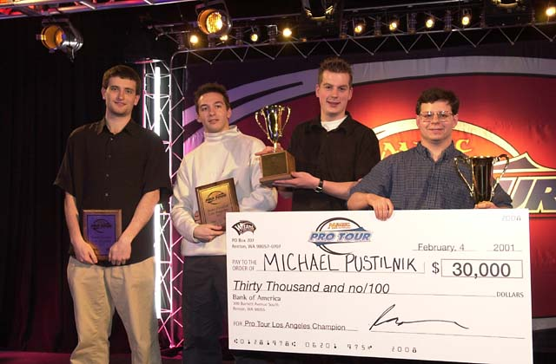
Mike Pustilnik is the winner of Pro Tour: Los Angeles. "Mikey P" is a veteran pro from Brooklyn, NY and is much respected by fellow players. Pustilnik got his first title finish at Pro Tour: New York several years ago, where he placed in the Top 8. Last season he won Grand Prix: Memphis, unveiling a Squirrel Prison deck. This season Pustilnik has been on fire, earning a Top 8 and several Top 16 and Top 32 finishes in various Grand Prix, then finishing in the Top 8 of Pro Tour: Chicago.
Finalist Kamiel Cornelissen is generating at least as much buzz as the winner. Cornelissen's first ever Pro Tour was in New York last year, where he finished 11th. Since then, Cornelissen placed 23rd in the team Pro Tour, 2nd in Chicago and now 2nd again in Los Angeles, prompting people to wonder whether he might be the next Finkel.
Finkel himself reasserted his dominance with yet another Top 4 finish. Although Cornelissen managed to upset him 3-0 in their semifinal match, it will take a lot more top finishes to unseat Finkel as the #1 player in the game.
Los Angeles was the first Pro Tour where a new policy of allowing all players who share the same match record as the 96th place finisher to compete on Day 2 was instituted. Players at a 4-3 record made it in, allowing literally over half of the competitors to play in Day 2. Although there were some minor glitches with the DCI Reporter software toward the end of Day 1, the fact that over 160 players competed on Day 2 seemed to cause no problem at all, and the policy is likely to stand.
Complete coverage of this Pro Tour can be found here.

COMING UP: GRAND PRIX VALENCIA AND KAOHSIUNG
Talk about exciting locations - far from everyone even recognizes the names of the two cities that are about to host Grand Prix tournaments for the first time.
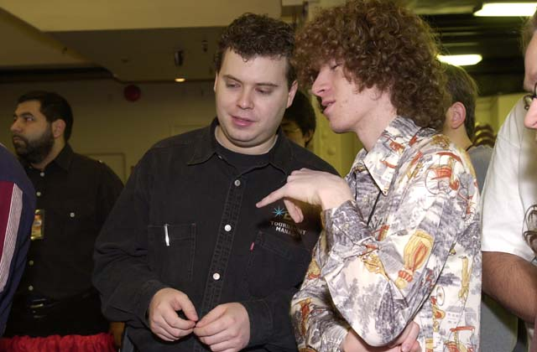
Sideboard writer Josh Bennett will be providing Sideboard coverage from GP Kaohsiung
Valencia is a city in Spain. Combine the fact that Spanish and Portuguese Grand Prix have drawn some of the largest crowds in GP history (GP Lisbon was the largest title event outside of Asia, at 747 players) with the fact that it happens to be a qualifier for PT Barcelona - a Pro Tour in their own country - and you can count on a very heavy turnout. Many of the North American pros will show up there as well.
Kaohsiung is the second largest city in Taiwan, and one of the largest seaports in Asia. Although Taiwanese players are enthusiastic, the crowds this tournament is likely to gather aren't nearly as great. If the two Grand Prix held in Taiwan's capital Taipei are any indication, there should be about 200-250 players attending.
These Grand Prix will be the first two events to use Planeshift cards at high level tournament play. It will be a rare opportunity for those players who are able to figure out the power of the new cards quickly to have some real advantage over the rest of the field.

GOOD BYE, BOAT
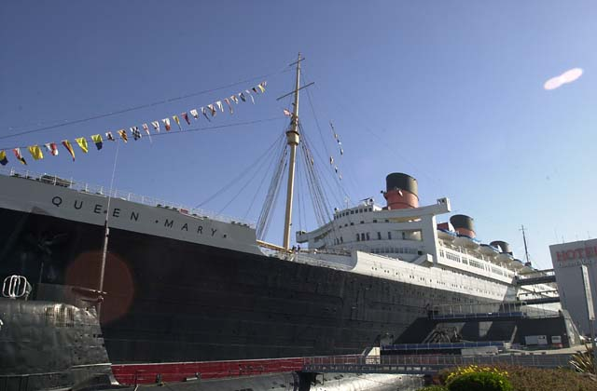
Pro Tour: LA that took place last weekend is likely to be the very last time a Pro Tour is held on Queen Mary (lovingly referred to as "The Boat" by pro players, most of whom see it as the best of the regular Pro Tour stops).
Over the course of next year, the convention area of Queen Mary will be closed for renovations. It is very possible that, once the renovations are complete, the convention space remaining will simply not be large enough to host a Pro Tour. Thus, Wizards of the Coast will be looking for a different location for a Pro Tour next year. It may be difficult, but let's hope they can find one that will match the now legendary Boat in its quality.

PRO TOUR PLAYER OF THE YEAR RACE UPDATE
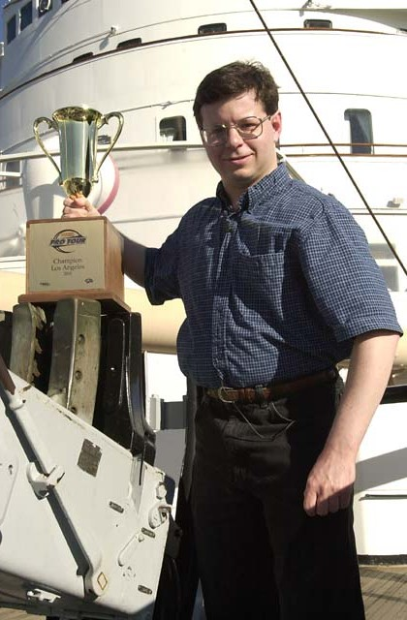
Top 10
55 Mike Pustilnik
52 Kamiel Cornelissen
47 Kai Budde
40 Scott Johns
37 Gary Wise
35 Mike Turian
34 Robert Dougherty
31 Jon Finkel
26 Benedikt Klauser
24 Noah Boeken
Budde enjoyed a solid lead at 41 points, going into this event. It seemed unlikely that he would be unseated, even if he had a bad weekend. Despite making Top 32, Budde has now been pushed to 3rd place.
Three competitors made their second Top 8 in a row - Cornelissen, Finkel, and Pustilnik. Cornelissen's two Top 2 finishes give him a very strong 52 point record, but they do not beat Pustilnik's win, Top 8 finish, and a number of solid Grand Prix records this season.
Members of Team Potato Nation all posted strong finishes in Los Angeles, allowing them to remain within striking distance of the top. Rob Dougherty gained on them just a little with a top 16 finish.
Noah Boeken managed to make the top 10 without a Pro Tour top 8 finish. He has a 14th place finish in the Team Pro Tour, two top 64's, a Grand Prix win and a GP top 4. He is trailed by a single point by his PTNY teammates Ryan Fuller and Chris Benafel. The entire team has been riding the Grand Prix circuit hard this season, and will likely continue to do so, but a top Pro Tour finish will clearly be needed this year for anyone with any hope of winning the title.
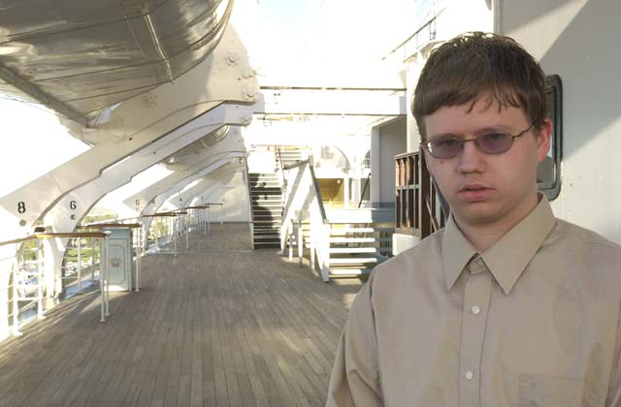
Rookie of the Year leader, Lawrence Creech
In Rookie of the Year race, Lawrence Creech has a strong lead at 18 points thanks to his Top 8 finish in LA and Top 32 in Chicago. Creech is followed at 13 points by Johan Sadeghpour, who finished just below the breaking points at 9th and 17th in the last two PTs.
There will be a total of six Grand Prix held until the next Pro Tour, but they will be held over three weekends, giving all those interested a chance to try and gain more points three times. No major upsets are likely to come out of these events, but the players at the top will have an opportunity to consolidate their positions, while others can pick up points in hope of a top finish at one of the three remaining Pro Tour stops this year.

TRADING TRENDS
In last week's column, I mistakenly announced that all foil Legend cards in Planeshift feature the alternative artwork. In fact, each foil card has regular and alternative artwork versions. I apologize for any inconvenience this error may have caused you, and thank all those who e-mailed me with corrections.

MAGIC TRIVIA
Last week's questions:
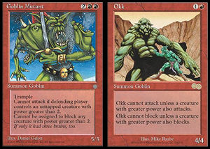
There are two specific Goblins in play. One of them may ONLY attack if the other one attacks. What are the two Goblins?
The two goblins are Okk and Goblin Mutant. Okk can only attack when a creature larger than itself also attacks. Goblin Mutant is the only goblin larger than Okk.
There is a way to take mana burn twice in the same phase. How can this be done?
You need to have Oath of Lim Dul in play. When you take mana burn for the first time, sacrifice a Su-Chi or Cathodian instead. You can then burn the mana generated by one of these creatures.
This week, I would like to try something a little different. There are lots of interesting facts about Pro players, judges, tournament organizers and WOTC staff you probably do not know. Below is a list of amusing anecdotes, followed by a list of notable people in the Magic community. Everything listed below is true, and relates to one of the people listed below. Try to match the anecdote with the person. It may be pretty hard!
Please do not e-mail me with your answers. There is no prize, this is strictly for fun. Correct answer will be posted in the next week's column.
- Beat Tiger Woods in a round of golf
- Starred in TV commercials
- Wrestled in Ramen noodles
- Family owns a jet
- Taught ballroom dancing
- Wrote for "Roseanne" TV show
- Air Hockey world champion
- Used to arm-wrestle professionally
- Published science-fiction author
- Lives in a palace
List of answers (in alphabetical order):
Michelle Bush
Brian Hacker
Darwin Kastle
Nicolas Labarre
Bob Maher
Sean "Hammer" Reignier
Ben Ronaldson
Mark Rosewater
Brian Selden
Tim Weissman
If you have some other interesting facts about well-known Magic figures, please let me know. If there are enough, we can have a second installment of such trivia.

BEST OF THE NET

This week's top prize goes out to Israel Marques of Star City. Marques has a very unique style, as you will undoubtedly notice if you read any of his articles. I especially liked his very recent examination of a U/W Prison deck. Talking pure strategy, his analysis cannot hope to match those of top Pro players like Zvi or Darwin Kastle, but it is solid strategy for PTQ-level players, and it is written in a very entertaining and highly amusing fashion.

WAR OF THE INTERNET WRITERS
Webmasters of CCGPrime.com are hosting a very amusing contest called War of the Internet Writers. Log on to vote for your favorite Internet authors, separated into pools of 8. Top 32 will go on to the "single elimination" format. I am not sure how exactly this is going to work, but it sounds quite interesting. Check out the voting pools here. You know who to vote for in Pool #8, don't ya? :)

PLAY OF THE WEEK
Thanks to Carl Jarrell for submitting the following play.
This took place over a year ago, during the brief period of time when Memory Jar was legal in Extended, prompting many players to build and use incredibly broken combo decks, capable of winning as quickly as turn 1-2.
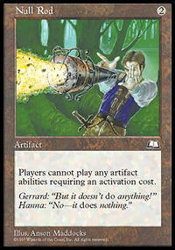
It was game three between a Jar deck and a Necro deck. After the first game, Necro player sideboarded a lot of cards - but they did not show up in the second game and he lost that one. In the third game, Necro player went first. He opened with Swamp, Dark Ritual, Demonic Consultation, naming Null Rod, with enough mana left over to cast it!
Jar player had no Force of Will, nor a way to deal with Null Rod. Rather than hope for a bad Consult, he conceded the game. Too bad for him - the Necro player did not actually have any Null Rods in his deck or sideboard!
I was not sure what category this belongs in. No one should ever concede in response to Demonic Consultation - but the sheer audacity of the Necro player combined with the fact that his gambit actually paid off, makes for a solid play of the week.

BAD PLAY OF THE WEEK
This took place at the first round of PTLA last weekend. Jay Elarar faced Matt Vienneau in an all-Canadian feature match. Elarar used cards like Probe to get rid of every card in Vienneau's hand. Things were looking fine for Vienneau though - he had Crosis the Purger in play, along with Benalish Heralds - with plenty of mana untapped.
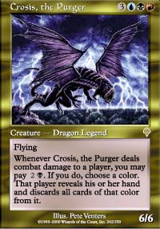
On his turn, Elarar drew Recoil - perhaps the only way in his deck to deal with Crosis. The correct play would have been to announce his end of turn step, allow Vienneau to put the Heralds' card drawing ability on the stack, and resond by casting Recoil - sending the Dragon to the graveyard, with a short stop-over at Vienneau's hand.
Elarar did not think that far. He cast Recoil during his main phase.
Bad play, right? It got worse.
Vienneau picked up the Dragon, and put it in his graveyard.
At the end of Elarar's turn, Vienneau went on to activate his Benalish Heralds, realize his mistake, and go "D'oh!"
As always, please send good/bad plays and other news to ashv@concentric.net

